Users:

Products:


Orders:
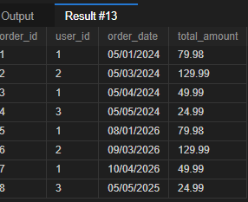
Order details:
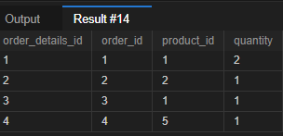

1. List all customers who have made purchases of more than $80.
SELECT u.user_id, u.name, SUM(ord.total_amount) AS total_spent
FROM users u JOIN orders ord on u.user_id = ord.user_id
group by u.user_id having total_spent > 80;

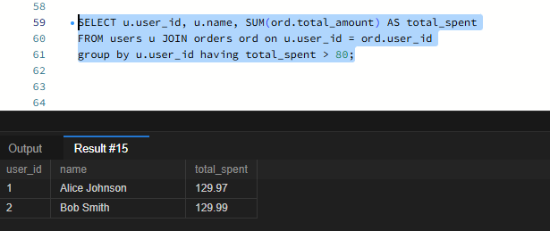
2. Retrieve all orders placed in the last 280 days along with the customer name and email.
SELECT
o.order_id,
u.name AS customer_name,
u.email,
o.order_date,
o.total_amount
FROM Orders o
JOIN Users u
ON o.user_id = u.user_id
WHERE o.order_date >= DATE_SUB(CURDATE(), INTERVAL 280 DAY);

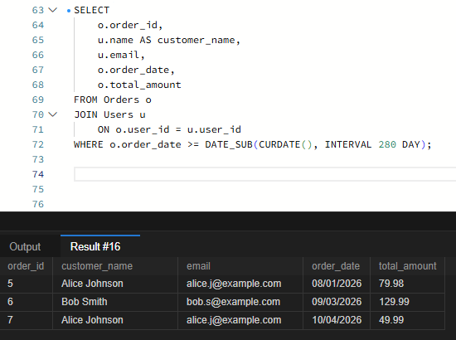
3. Find the average product price for each category.
SELECT
category, AVG(price) AS avg_amount
FROM Products
GROUP BY category;
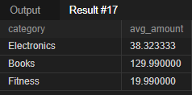
4. List all customers who have purchased a product from the category Electronics.
SELECT DISTINCT
u.user_id,
u.name AS customer_name,
p.name,
od.quantity
FROM Users u
INNER JOIN Orders o
ON u.user_id = o.user_id
INNER JOIN OrderDetails od
ON o.order_id = od.order_id
INNER JOIN Products p
ON od.product_id = p.product_id
WHERE p.category = 'Electronics';

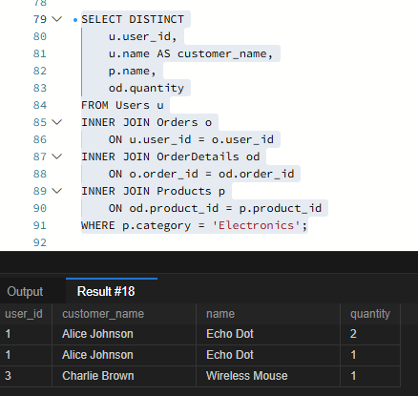
5. Find the total number of products sold and the total revenue generated for each product.
SELECT DISTINCT
p.name,
SUM(od.quantity) as tot_qty,
SUM(od.quantity * p.price) as tot_revenue
FROM Products p
INNER JOIN OrderDetails od
ON p.product_id = od.product_id GROUP BY p.product_id;


6. Update the price of all products in the Books category, increasing it by 10%.(used Electronics)
UPDATE products set price= price * 1.10 where category='Electronics';



7. Remove all orders that were placed before 2020.
DELETE FROM
Orders
WHERE
order_date < '2020-01-01';

8. Write a query to fetch the order details, including customer name, product name, and
quantity, for orders placed on 2024-05-01.
SELECT
o.order_id,
u.name AS customer_name,
p.name as product_name,
od.quantity
FROM Orders o
JOIN Users u
ON o.user_id = u.user_id
JOIN Orderdetails od
ON o.order_id=od.order_id
JOIN products p
ON od.product_id = p.product_id
WHERE o.order_date = '2024-5-01';


9. Fetch all customers and the total number of orders they have placed.
SELECT
U.name AS customer_name,
U.email,
COUNT(O.order_id) AS total_orders
FROM
Users U
LEFT JOIN
Orders O ON U.user_id = O.user_id
GROUP BY
U.user_id;

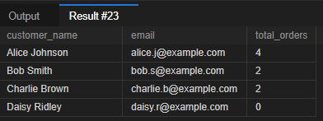
10. Retrieve the average rating for all products in the Electronics category.
11.List all customers who purchased more than 1 units of any product, including the product
name and total quantity purchased.

SELECT
u.user_id,
u.name AS customer_name,
p.name,
SUM(od.quantity) as total_order
FROM Users u
JOIN Orders o
ON u.user_id = o.user_id
JOIN OrderDetails od
ON o.order_id = od.order_id
JOIN products p
ON od.product_id = p.product_id
GROUP BY u.user_id, p.product_id
HAVING total_order>1;

12. Find the total revenue generated by each category along with the category name.
SELECT DISTINCT
p.category,
SUM(od.quantity * p.price) as tot_revenue
FROM Products p
JOIN OrderDetails od
ON p.product_id = od.product_id
GROUP BY p.category;


